

Script Executor

user guide V0.1



Contents

1. Introduction 3

2. Prerequisites 3

3. Purpose 3

4. Using the Business Object 4

4.1. Script Executor 4

5. Support 5

6. Functional Tests 5

*7.* Troubleshooting Guidelines 5

8. Frequently Asked Questions 5

The information contained in this document is the proprietary and confidential information of Blue Prism Limited and should not be disclosed to a third party without the written consent of an authorised Blue Prism representative. No part of this document may be reproduced or transmitted in any form or by any means, electronic or mechanical, including photocopying without the written permission of Blue Prism Limited.

**© Blue Prism Limited, 2001 – 2020**®Blue Prism is a registered trademark of Blue Prism Limited

All trademarks are hereby acknowledged and are used to the benefit of their respective owners.  
Blue Prism is not responsible for the content of external websites referenced by this document.

Blue Prism Limited, Centrix House, Crow Lane East, Newton-le-Willows, WA12 9UY, United Kingdom  
Registered in England: Reg. No. 4260035. Tel: +44 870 879 3000. Web: www.blueprism.com

# Introduction

This asset is designed to assist in the execution of a script and return its value into Blue Prism. This VBO is to compliment the information provided in the Code Stages document provided on the Blue Prism Digital Exchange developer area <https://blueprism.developerprogram.org/site/global/developer/integration/index.gsp>

# Prerequisites

To use this asset, you require a licenced Blue Prism installation or trial. More information on Blue Prism can be found here.

You will also require the current version of a scripting engine. Examples of which are Python and NodeJS. You can download Python from <https://www.python.org>. Node JS can be downloaded from <https://nodejs.org>

These are the two-scripting engines we have tested with this asset. Others that follow a similar file structure should work the same way.

You will need to be comfortable with building Blue Prism processes and how to locate files on your computer.

Unless you wish to modify this asset, no experience of .NET Development is necessary.

The asset is created as a *bprelease which contains both a VB and a C# object version*, so that it may be reviewed and edited as you find necessary. It is maintained on a best endeavours’ basis by *Blue Prism* however, user feedback is appreciated, and this can be in relation to issues or errors found and feature requests.

# Purpose

This asset is intended to make it easier to call into scripts. It makes use of a code stage to execute the scripting runtime and run the script, script arguments are supported also. Scripts can be chained together in a process easily.

If you are interested in the code that this VBO uses, there are both C# and VB versions to review.

# Using the Business Object

:

## Script Executor

Inputs

| Name | Description | Data Type |
| --- | --- | --- |
| ScriptEngineFilePath | The location of the scripting engine executable on your computer. | Text |
| ScriptFilePath | The location of the script that you wish to execute. | Text |
| ScriptFileAndArguments | The script name and any arguments that your script might need. | Text |

It should be remembered that all file path values need to make use of the double backslash to separate out the path elements. This is because of how the backslash is interpreted by the .net languages. For any path errors that are reported this is the first thing to check.

Outputs

| Name | Description | Data Type |
| --- | --- | --- |
| ScriptOutput | The results of any output from your executed script. | Text |

The output will be all resulting text that your script will have produced from its invocation. It may be necessary to modify the script so that output is delimited in such a way that required results can be easily accessed through string manipulation.

Alternatively, your script could write results to a file and then read those results into Blue Prism with a file access action.

# Support

Support for this skill is provided via the Blue Prism Digital Exchange Community Forum. Post your questions here:

[Digital Exchange Community Forum](https://community.blueprism.com/communities/community-home?communitykey=1e516cfe-4d1f-4de9-a9eb-58d15bf38c81&tab=groupdetails)

# Functional Tests

There is a simple test process supplied in the release file. We have not tested this asset beyond the execution of our own scripts. Blue Prism does not guarantee this VBO asset as being suitable for any specific purpose and it is up to the customer to ensure it meets their requirements. Use of this VBO asset is acceptance of this understanding.

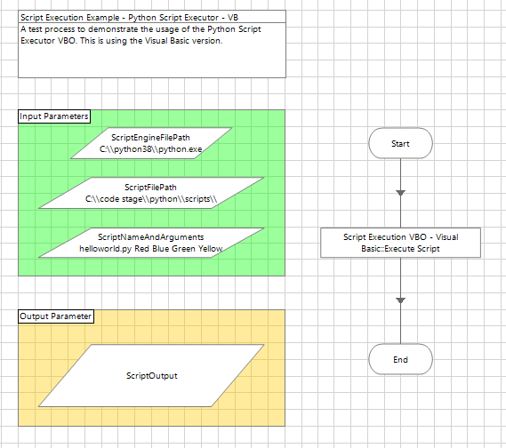

The Script Executor Test Process

The input parameters are where you will insert values that meet your requirements. The *ScriptEngineFilePath* parameter is the location of the scripting runtime on your computer. This will have been decided at the time you installed the engine on your system. The *ScriptFilePath* is the **location** of the script file you wish to execute and finally the *ScriptFileAndArguments* is the actual script name **and** any additional values that your script requires.

Ensure that any file paths use double backslash to separate the drive-directory boundaries. For example, C:\\python\\my work\\. This is essential for the asset to work.

The release includes both the C# and the VB versions, in case you have an affinity for one language over the other.

# Troubleshooting Guidelines

It should be noted that file paths that contain spaces, can cause some issue with the way that this VBO is created. The VBO has been created to trap errors and direct them out into the *scriptOutput* variable. The main issue you may find with this asset is a path with spaces in it.

# Frequently Asked Questions

There are no frequently asked questions at this stage.